- Solve: $35 \left(7-3\right)=$
- Solve: $24÷\left(15-11\right)=$
- Solve: $7-\left(-4+5\right)=$
- Solve: $12-\left(-5+3\right)=$
- Solve: $3+\left(12-6\right)-16=$
- Solve: $7 \left(4÷2\right)÷7=$
- Solve: $\left(3x^{4}\right)\left(4x^{2}\right)=$
- Simplify: ${(2x}^{2})$²
- Simplify: $(x$⁶$)$ ⁷
- Simplify: $5\left(x+4\right)+2(3x-6)$
- Simplify: $2\left(-3x-4\right)-3(5x+2)$
- Simplify: $\frac{10x^{2 }+ 5x}{5x}$
- Simplify: $\frac{6a^{2}b}{-2ab^{2}}$
- Calculate: $7(a+c+b)$
- Calculate: $(m^{2})(p+u)(m-p+u)$
- Calculate: $(4x-7)$²
- Calculate: $\left(2x+4\right)\left(3x-5\right)$
- If A = BC, please solve for C
- If X = YZ, please solve for Y
- Solve for r: $24=32-r÷6$
- Solve for y: $y+42=27$
- Solve for x: $x-9=2x+15$
- Solve for z:
$$-11+10z+11+\left(-33\right)=z+2z+100$$

- Solve for w:
$$w+3+w+4=w+7+2w+7$$

- Solve for g:
$$-7+g+4+4g=g+\left(-3\right)+6+3g$$

- Solve if r=7 $-3r^{2}-4r=$
- Solve if y=5 $40-(4y+15-1y)$=
- Solve if x=3 $(x•4)$²=
- Solve if z=6 $7^{2}•z^{4}-42+11=$
- Solve if g=21 $\frac{4g}{4}$
- Solve if w=4 $\frac{108w•3+304}{200w}=$

- Write the following as an expression: Multiply A times seven and then divide the result by B.

- If the total cost of x apples is b cents, what is a general formula for the cost, in cents, of y apples?

- If I sold 125 books and 21 are returned to me, what percentage of books were returned? (Round your answer to the “tenths” place)

- The cost of two tables and three chairs is $705. If the table costs $40 more than the chair, find the cost of the table and the chair.

ANSWERS:

- 140
- 6
- 6
- 14
- -7
- 2
- 12x⁶
- 4x⁴
- X⁴²
- 11x + 8
- -21x – 14
- $2x+1$
- $\frac{-3a}{b}$
- 7a + 7c + 7b
- m³p– m²p² + m³u + m²u²
- 16x² – 56x + 49
- 6x² + 2x – 20
- $C=A÷B$
- $Y=X÷Z$
- R = 48
- Y = -15
- X = -24
- Z = 19
- W = -7
- G = 6
- -175
- 10
- 144
- 63,473
- 21
- 2
- 7$A÷B$
- $by÷x$
- 16.8%
- Chair $125, Table $165

MECHANICAL EXAM PRACTICE

- Would B be able to lift more or less than 80 lbs on its end?

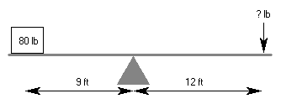

B
A

- Which weight requires the least force to move?

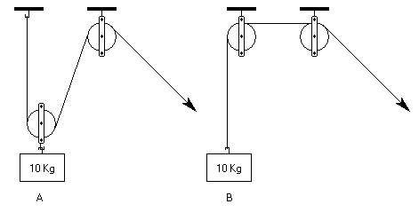

- Which weight requires the least force to move?
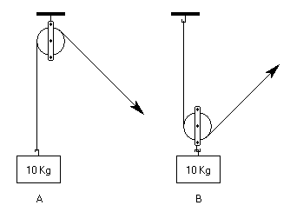

- How many switches need to be closed to light up one bulb?
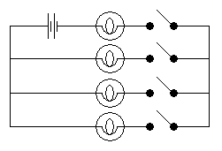

- You put the same amount of weight at the end of these two pendulums. If you let go of the two pendulums at the same time, which will swing back and forth more times in a minute?
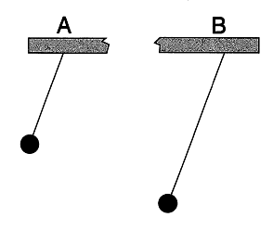

- These stools are the same height. Which is more likely to tip over when an active child sits on it?

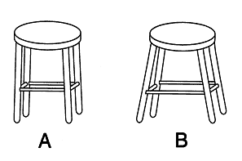
- Which wrench will make it easier to tighten the bolt?

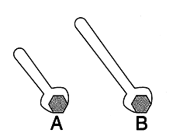
- Which wheel is turning faster?

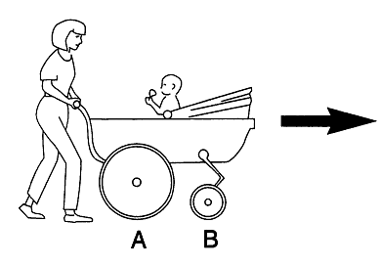
- What would a glass rod look like when immersed in water?
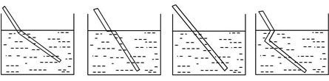
C
D
B
A

- At which point will the ball go faster?

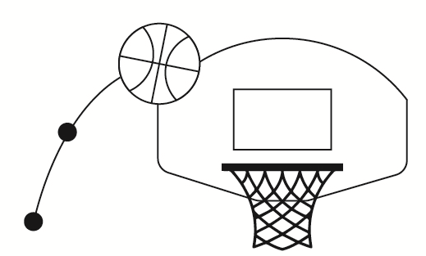
A
B

- Which measuring cup is marked correctly?

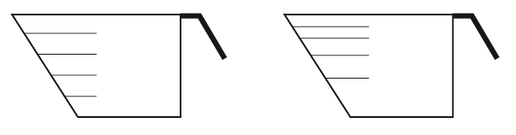
1 cup
3/4
1/2
1/4
1/4
1/2
3/4
1 cup
B
A

- If a boat and bowling ball fall off a 200ft. cliff at the same time, which would hit the ground first?
- Boat
- Ball
- Both
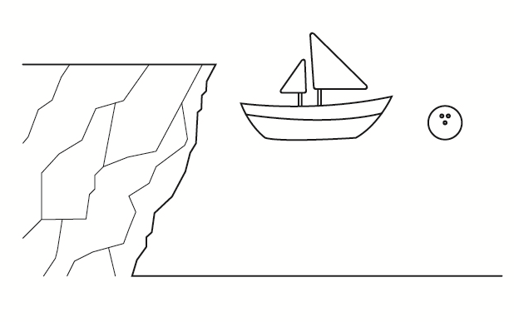
A
B

- Which pair of scissors will cut through cardboard easier?
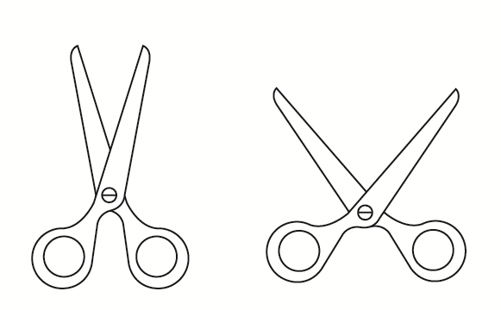
B
A

- Which box is heavier?

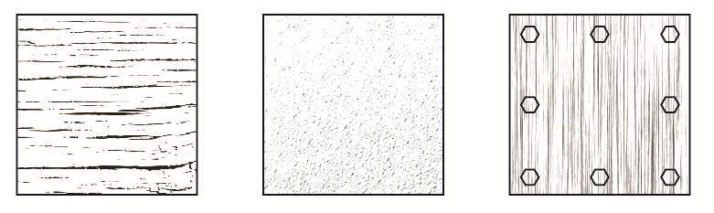
Metal
C
Plastic
B
Wood
A

- If the cart is moving in the direction of the arrow and suddenly stops, which direction will the pop fall?
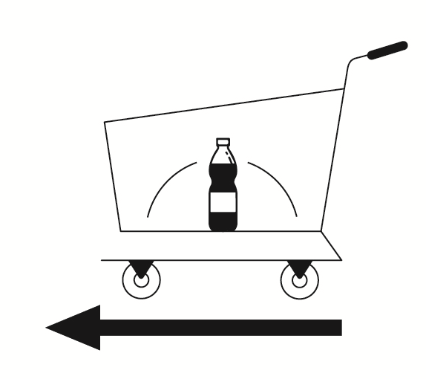
B
A

- If pulley #1 is moving clockwise, which direction is pulley #3 moving?
- Clockwise
- Counterclockwise
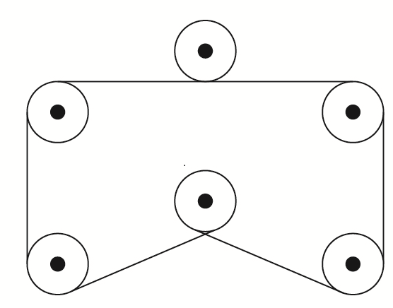
4
5
2
6
3
1

- Which gear will turn fastest?

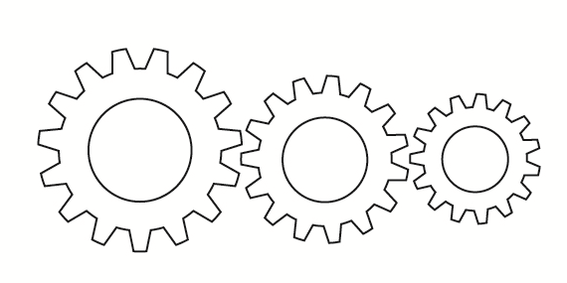
A
B
C

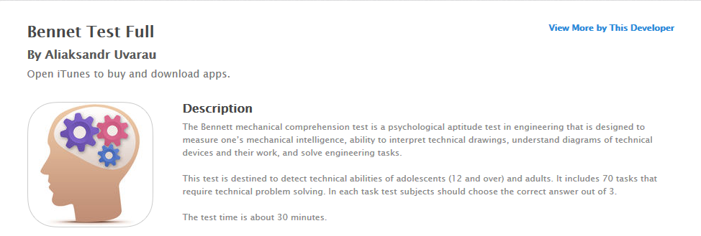
Mechanical Test
Practice Phone App:
Bennet Test Full
By Aliaksandr Uvarau
$0.99 iTunes
$0.99 Google Play

There is a free version of this app; however, it does not provide reasoning to the solutions. We recommend purchasing the $0.99 version because it provides detailed solutions to the 70 questions.

ANSWER SHEET:
- More 10. A

- A 11. B

- B 12. C

- 2 13. B

- A 14. C

- A 15. A

- B 16. B

- B 17. C

- A

Accuplacer Reading Review
*The following Accuplacer reading review is from EBSCO host’s Learning Express web site. The reading review’s content was drawn from Learning Express’s web site and can be found in the College Center under the preparing for college placement exams section (http://www.learningexpresshub.com/productengine/LELIndex.html#/college-center/resources/prepare-for-college-placement-exams/accuplacer-preparation/accuplacer-reading-comprehension-practice-tests). Free access to the Learning Express website is granted to any person with a Yakima Valley Libraries library card.
1) Choosing a doctor is an important decision. Here are some things you can do to make the best choice. The single most important thing is to interview the doctors you are considering. Ask questions about the practice, office hours, and how quickly he or she responds to phone calls. Pay attention to the doctor’s communication skills and how comfortable you are with him or her. The second thing you should do is check the doctor’s credentials. One way to do this is to ask your health insurance company how they checked the doctor’s credentials before accepting him or her into their network. Another thing you can do is to look at the environment of the doctor’s office. Be sure patients aren’t waiting too long and that the office is clean and professional. Finally, spend some time talking with the receptionist. Keep in mind that this is the person you’ll come into contact with every time you call or come into the office. If he or she is pleasant and efficient, it will certainly make your overall experience better.
- According to the paragraph, the primary way to choose a doctor is:
- To conduct an interview with the doctor.
- To ask your health insurance company to provide you with credentials for the doctor.
- To talk to the receptionist to make sure the office runs efficiently.
- To observe the environment in the doctor’s office to make sure it is clean, professional, and wait times are reasonable.

2) Voting is a privilege for which wars have been fought, protests have been organized, and editorials have been written. "No taxation without representation" was a battle cry of the American Revolution. Women struggled for suffrage, as did all minorities. Eighteen-year-olds clamored for the right to vote, saying that if they were old enough to go to war, they should be allowed to vote. Yet Americans have a deplorable voting history.
Interviewing people about their voting habits is revealing. There are individuals who state that they have never voted. Often, they claim that their individual vote doesn’t matter. Some people blame their absence from the voting booth on the fact that they do not know enough about the issues. In a democracy, we can express our opinions to our elected leaders, but more than half of us sometimes avoid choosing the people who make the policies that affect our lives.
- The author of the passage implies that:
- Not voting is an understandable choice for those who do not know enough about the issues.
- Voting is an obligation and duty of citizenship.
- In a democracy our power to make change is so limited that voting is not an imperative.
- America’s voting history is laudable.
Accuplacer Reading Review
3) Although it is called Central Park, New York City’s great green space has no "center"—no formal walkway down the middle of the park, no central monument or body of water, no single orienting feature. The paths wind, the landscape constantly shifts and changes, the sections spill into one another in a seemingly random manner. But this "decentering" was precisely the intent of the park’s innovative design. Made to look as natural as possible, Frederick Law Olmsted’s 1858 plan for Central Park had as its main goal the creation of a democratic playground—a place with many centers to reflect the multiplicity of its uses and users. Olmsted designed the park to allow interaction among the various members of society, without giving preference to one group or class. Thus, Olmsted’s ideal of a "commonplace civilization" could be realized.
- From explicit statements in the passage, Olmsted’s ideal of a “commonplace civilization” means:
- A natural paradise in the center of the city.
- A shifting landscape of paths and playgrounds that civilizes the surrounding natural beauty.
- A place for the common man to escape the stresses and drudgery of everyday life.
- A park that knows no social barriers and encourages the mixing of social classes.

4) Robert Johnson is the best blues guitarist of all time. There is little information available about this legendary blues guitarist, and the information is as much rumor as fact. What is indisputable, however, is Johnson’s tremendous impact on the world of rock and roll. Some consider Johnson the father of modern rock: His influence extends to artists from Muddy Waters to Led Zeppelin, from the Rolling Stones to the Allman Brothers Band. Eric Clapton has called Johnson the most important blues musician who ever lived. Considering his reputation, it is hard to believe that Johnson recorded only 29 songs before his death in 1938, purportedly at the hands of a jealous husband. He was only 27 years old, yet he left an indelible mark on the music world. Again and again, contemporary rock artists return to Johnson, whose songs capture the very essence of the blues, transforming our pain and suffering with the healing magic of his guitar.
- The author would most likely end the passage with which of the following sentences?
- The 1990 box set of Johnson’s complete recordings enjoyed unprecedented sales.
- Robert Johnson was born over 100 years ago in the backwaters of Mississippi.
- Although his contribution is minor, thousands of new fans discover Johnson’s soulful voice and masterful guitar every year.
- Rock music wouldn’t be what it is today without Robert Johnson.

5) Planting a garden is a lot like having a family. A plant becomes dependent on the gardener and begs for water on a hot summer day. Gardeners also have to clean up the space around their plants as they shed spent petals, as they require pruning, and as they become choked with weeds. Gardeners also provide for the health of their plants through insecticide and fertilizer applications. A gardener’s responsibility for his or her plants lessens as they die at the end of the season or they go into winter dormancy. Like gardeners, parents find their children dependent upon them for food and nourishment. Like gardeners, parents are constantly picking up after their children, as toys and clothes are scattered throughout the house. Like gardeners, parents provide for the nourishment and well-being of their

Accuplacer Reading Review
children with vitamin supplements, food, and medicines. However, unlike gardeners, parents will find that their responsibility lessens as the child grows, but it does not come to an end.
- According to the passage, the main difference between gardeners and parents is:
- Gardeners have to apply insecticide and fertilizer unlike parents.
- Gardeners have to clean up spent petals, prune, and week unlike parents.
- Plants become dependent on gardeners for water on hot summer days.
- Gardeners’ responsibilities never lessens year after year unlike parents who will enjoy decreasing responsibility with advancing years.

6) Coach Lerner, my basketball coach, is six feet ten inches tall with a voice that booms like a foghorn and the haircut of a drill sergeant. Every morning, he marches onto the basketball court at precisely 8:00 and dominates the gymnasium for the next three hours. He barks orders at us the entire time and expects that we will respond like troops on a battlefield. And if we fail to obey his commands, he makes us spend another 45 minutes under his rule.
- Which of the following best describes the mood of the author?
- Exasperation
- Admiration
- Exultance
- Moroseness

7) Every morning when Clara arrives at the gym, she is greeted with a buzz of warm hellos. She starts her workout in the weight room, where her exercise regimen is always peppered with lively chats with those around her. She then moves on to the pool, where she stops and converses with other friends and acquaintances before diving in and swimming laps. As she swims, her sole focus is the calming sound of her body gliding through the water—a rare moment in her always very social days.
- The passage suggests that the part of her morning workout most prized by Clara is:
- Her workout in the weight room
- Her exercise regimen
- Her lively chats and conversations
- Swimming laps

8) Imagine how wonderful it would be if local residents had access to a community garden. Rather than gardening in isolation, residents would come together in an appealing designated spot to plant a bountiful garden. They would be given a plot of land within the large garden to plant as they see fit. They could plant flowers, vegetables, herbs, or any other greenery they desire. The requirement would be that they spend at least one hour in the garden every week and that they bring a few gardening implements to share, such as watering cans, gardening gloves, fertilizer, and shovels. The benefits of a community garden would be numerous. Residents would have access to land in which to garden they might not otherwise have. They would be part of a worthwhile and rewarding community activity that would allow
Accuplacer Reading Review
them to meet other residents who love gardening and who might have excellent gardening skills and hints to share. Additionally, a community garden would be a wonderful oasis in the middle of our busy town where residents can come to walk, sit, or just enjoy the company of neighbors in a lush and friendly setting.
- The passage mentions each of the following as a benefit of a community garden EXCEPT:
- Residents who do not have land to plant a garden would be able to grow vegetables
- Meeting and socializing with neighbors while being able to harvest vegetables
- The increased nutrition available from fresh, pesticide-free fruits and vegetables
- Creating a soothing retreat where residents can walk, sit, and enjoy one another’s company.

9) The Berkshire Park Community Center was damaged in a fire six months ago. Soon after, a committee of eight community members came up with the idea of an International Dinner to raise funds to repair the damages. The plan was to serve foods that represent the various cultures in the neighborhood. In addition, the committee organized a silent auction to take place during the dinner. Before the event, tickets were sold for $50 each. During the dinner, the committee chairperson talked to a local newspaper reporter and stated that the goal was to raise $10,000. Three hundred and fifty people attended the event, which raised $15,000. When the attendees left the event, they felt very good about their community. After the event, a letter was sent to community members thanking them for everything while outlining a schedule for renovation.
- The Berkshire Park Community Center used all of the following strategies to raise money to repair the fire damage on the facility EXCEPT:
- Holding an International Dinner
- Selling lottery tickets
- Getting the local newspaper to write a story about their event
- Holding a silent auction

10) This year’s employee awards ceremony was a tremendous success. The first award was given to Carlos Fe for Perfect Attendance. The second award, for Most Dedicated Employee, went to Jennifer Steele. Then our president, Martin Lucas, interrupted the awards ceremony to announce that he and his wife were having a baby. When he finished, everyone stood up for a congratulatory toast. Afterward, the third award was given to Karen Hunt for Most Inspiring Employee. Finally, President Lucas ended the ceremony by giving everyone a bonus check for $100.
- The purpose of this passage is to present:
- A personal observation.
- A solution to a problem.
- An account of an event
- Opposing points of view.

Accuplacer Reading Review
11) The worst and longest economic crisis in the modern industrial world, the Great Depression in the United States had devastating consequences for American society.
At its lowest depth (1932–33), more than 16 million people were unemployed, more than 5,000 banks had closed, and over 85,000 businesses had failed.
- What does the second sentence do?
- The first sentence explains the meaning of the second.
- The second sentence provides evidence for the first.
- The second sentence proposes a solution.
- The second sentence contradicts the first.

12) It may come as a surprise to current Milton Hershey fans, but his first candy success came with the manufacture of caramel.
After the failure of his Philadelphia store, Milton headed for Denver, where he learned the art of making caramels.
- What does the second sentence do?
- It restates the idea in the first sentence.
- It emphasizes what is stated in the first sentence.
- It compares an idea with the idea in the first sentence.
- It show a time order.

13) The most successful parties have a memorable style and theme that is introduced with the invitation and carries through to the choice of food, decorations, and entertainment, combining to produce an unforgettable event.
The best poems grab you with an electric opening and transport you on a emotional journey punctuated by vibrant, sensory imagery, producing and experience of enduring impact.
- What does the second sentence do?
- It restates the idea of the first sentence.
- It continues a sequence.
- It compares an idea with the idea in the first sentence.
- It continues a list.

14) After the housing bubble burst in 2008, median home prices in the United States dropped from $219,000 to $154,700 in 2012.
The subsequent decline in lending capacity and consumer consumption triggered a 6% annual rate of decline in the output of goods and services by the end of 2008, an increase in the unemployment rate to over 10%, and a decline in the average hours of work per week to 33.
- What does the second sentence do?
- It restates the idea found in the first.
- It states effects.
- It gives examples.
- It analyzes the statement made in the first.

15) In the 1980s, giant megamalls were developed.
The 5.3 million square foot West Edmonton Mall in Alberta, Canada, opened in 1981, with over 800 stores, 110 eating establishments, a hotel, an amusement park, a miniature-golf course, a church, a zoo, and a 438-foot-long lake.
- What does the second sentence do?
- It provides an example.
- It makes a contrast.
- It proposes a solution.
- It states an effect.

16) Anthropology is the study of human culture, both past and present, in order to understand the similarities and differences between how social relations are organized.
It combines the study of social patterns and practices; how biology interacts with culture; archaeological evidence of social group formation and human/environmental interactions; and how language reflects and influences social life (linguistic anthropology).
- What does the second sentence do?
- It expands on the first sentence.
- It makes a contrast.
- It proposes a solution.
- It states an effect.

17) Researchers studying unethical behavior believe that one reason people choose an unprincipled path is that they are blinded to the ethics of a situation due to the way in which the ethical dilemma is framed, a concept referred to as “bounded ethicality.”
The ethical big picture is overlooked because the context in which the decision is presented cognitively sets into motion a particular set of goals that supersedes ethical considerations.
- What does the second sentence do?
- It restates the central idea of the first sentence.
- It provides a contradictory point of view.
- It draws a conclusion from the first sentence.
- It provides supporting evidence for the first statement.

Accuplacer Reading Review
18) She suffered, feeling that every luxury should rightly have been hers.
The poverty of her rooms—the shabby walls, the worn furniture, the ugly upholstery caused her pain.
- How are the two sentences related?
- They repeat the same idea.
- They establish a contrast.
- They offer a cause and effect.
- They provide a statement and supporting example

19) August in London is lauded for its mild daytime temperatures under partly cloudy skies.
Our three day visit in sweltering over 90°F weather with torrential rainstorms and flash floods will never allow us to totally believe this.
- How are the two sentences related?
- They repeat the same idea.
- They provide a statement and supporting example.
- They offer a cause and effect.
- They establish a contrast.

20) Unbeknownst to me, an unexpected and unseasonal ice storm had deposited a half an inch of ice on my door stoop.
As I hurried out the door, my feet flew out from underneath me propelling my arms into the air and my portfolio of artwork into flight.
- How are the two sentences related?
- They repeat the same idea.
- They offer a cause and effect.
- They establish a contrast.
- They provide a statement and supporting example.

Accuplacer Reading Review

Works Cited
EBSCO Company. (2016). ACCUPLACER Reading Comprehension Practice Test 1. Retrieved from Learning Express College Center: http://www.learningexpresshub.com/productengine/LELIndex.html#/college-center/resources/prepare-for-college-placement-exams/accuplacer-preparation/accuplacer-reading-comprehension-practice-tests

Answers:
- A 11. B
- B 12. D
- D 13. C
- D 14. B
- D 15. A
- A 16. A
- D 17. A
- C 18. A
- B 19. D
- C 20. B

Please Visit the following web addresses for additional study resources:
ACCUPLACER’s Free Study App
https://accuplacerpractice.collegeboard.org/login

ACCUPLACER’s Free Study Packet
https://accuplacer.collegeboard.org/sites/default/files/next-generation-sample-questions-reading.pdf

Perry Technical Institute Web Site
https://www.perrytech.edu/admissions/enrollment.html

